**Folder Structure**

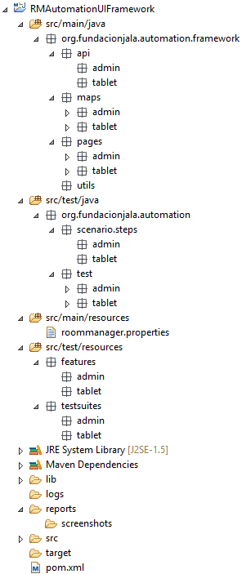

**Test Resources**

**Lib folder**

**Logs folder**

**Reports and screenshots**

**Pom.xml file**

**Resources**

**Scenario package**

**Test package**

**Utils package**

**API package**

**Maps package**

**Pages package**

**Maps**

The Maps package will contains all locators for all elements in the UI pages of Room Manager.

The Administrator and Tablet Module packages are divided in sub-packages that represent all the features in this module. (E.g.: Admin: Locations, Resources, Email Server, etc.) Inside these packages there will be classes that contain all the locators (E.g.: Xpath Locator, Id Locator, CSS Locator, etc.) for the pages that are part of these features. (E.g.: Locations: Locations Map, Create Location Map, etc.)

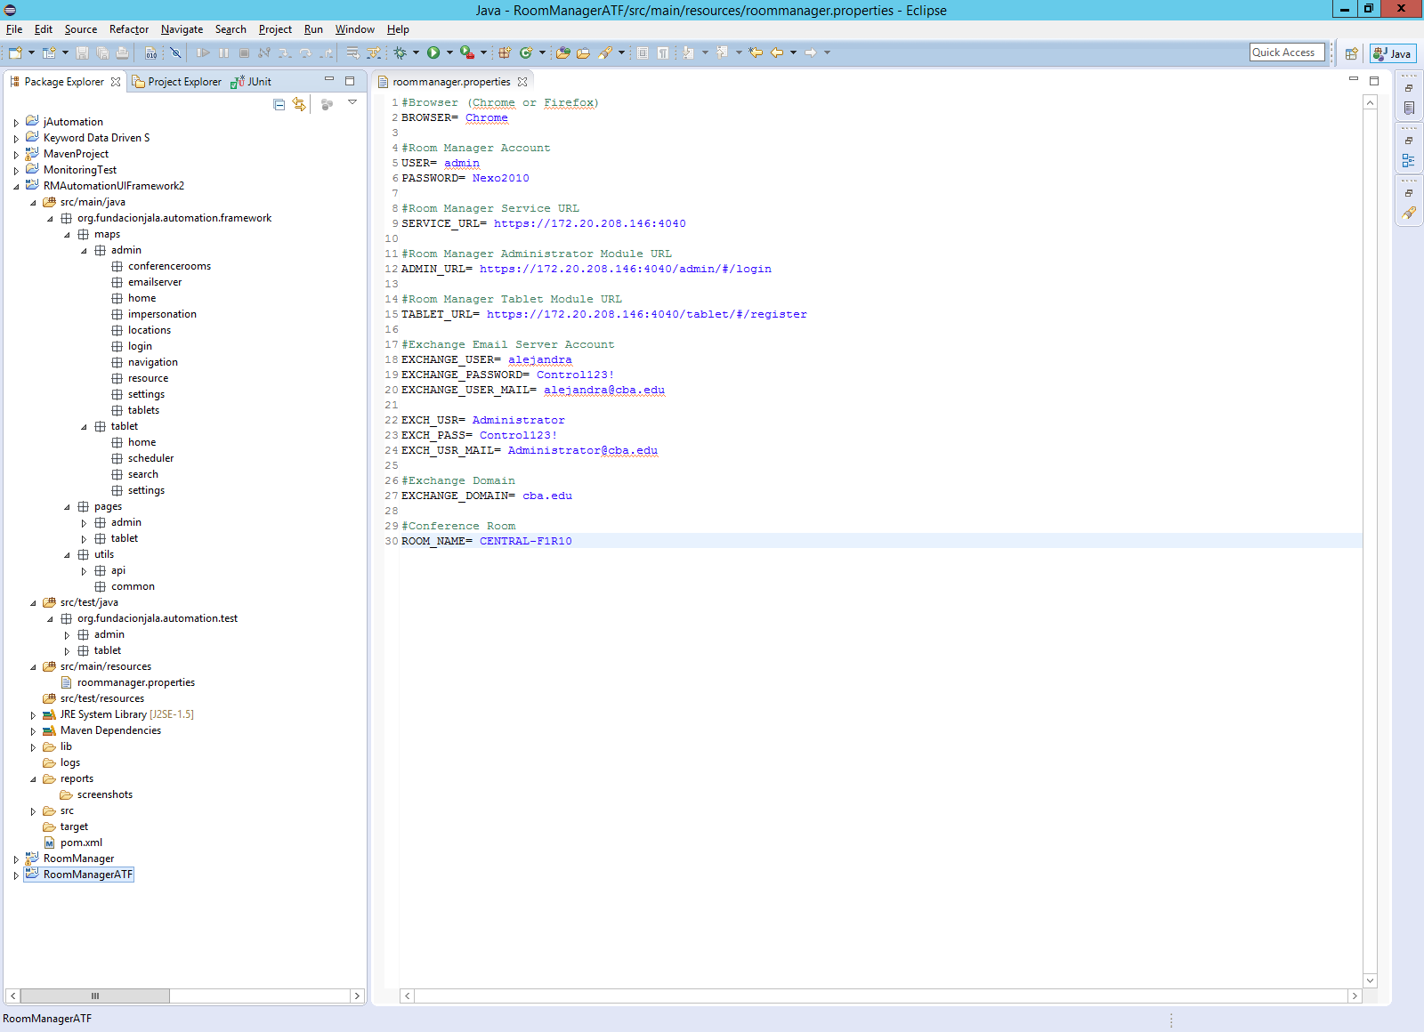

**Pages**

The Pages package will contains all Page Objects for all the features of Room Manager.

The Administrator and Tablet Module packages are divided in sub-packages that represent all the features in this module. (E.g.: Admin: Locations, Resources, Email Server, etc.) Inside these packages there will be classes that represents the Page Objects (E.g.: Locations: Locations Page, Create Location Page, etc.)

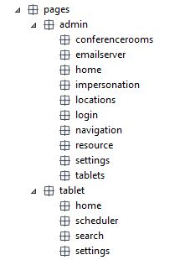

**API**

The API package contains the classes that will be used for generate all the pre and post conditions for all the test cases



**Utils**

The Utils package contains the common package will contains the common classes with functions that will be used in the framework



**Tests**

The Test package is divided in admin and tablet modules, these modules will contains all test cases according each feature

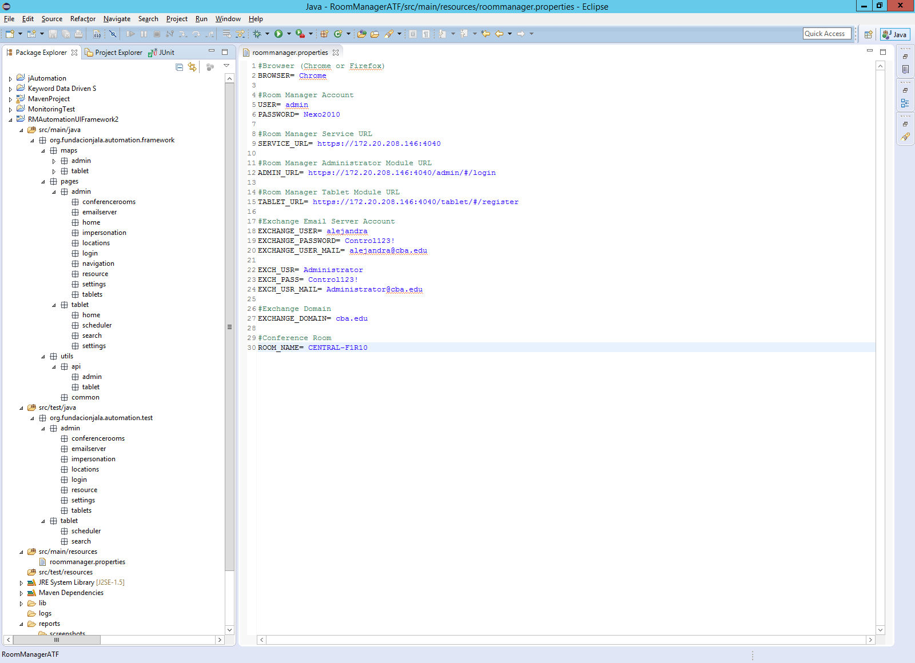

**Scenarios**

The Scenario package will contains all the steps and runner classes for all the scenarios.

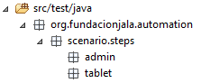

**Resources**

The main resource source folder will contain all the properties of the framework (E.g.: roommanager.properties)

The test resources sources folder will contain the test suites of the framework (E.g.: adminBVT.xml)



**Test Resources**

The test resources folder will contain the test suites of the framework (E.g.: adminBVT.xml) and the features for the scenarios.

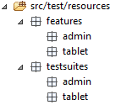

**Folders**

**Lib Folder:** This folder contains the external libraries that cannot be downloaded with maven

**Logs Folder:** This folder contains the log file

**Reports Folder:** This folder contains the reports that represent the test cases results

**Screenshots Folder:** This folder contains screenshot of test cases failed.

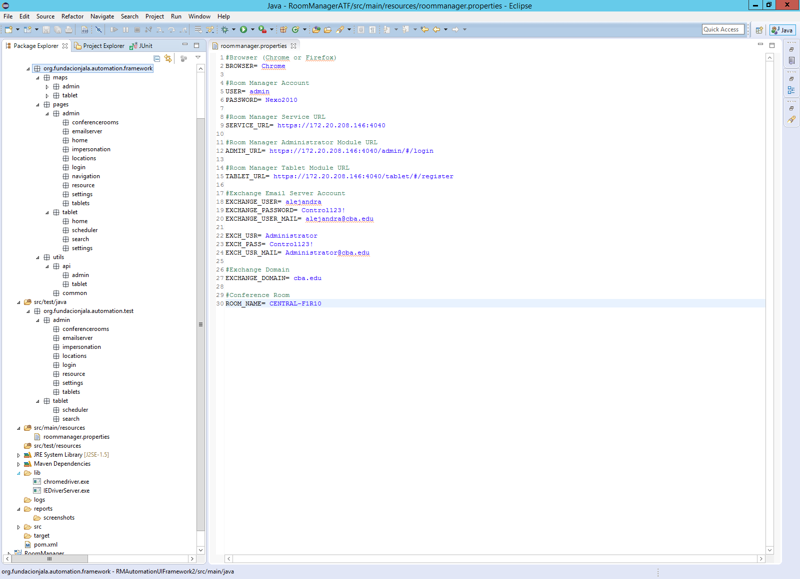

**Pom.xml file**

The pom.xml file contains all dependencies needed in our automation project for Room Manager

